Evaluation Warning: The document was created with Spire.Doc for Python.

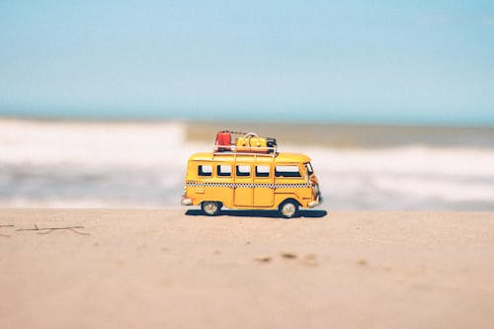



**Delhi to Nagpur Fun-filled Adventure**



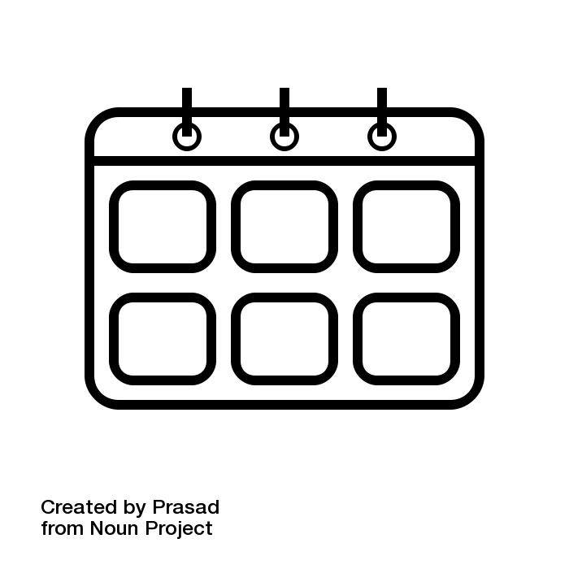Number of Days : 15

Budget Per Person : Rs. 50000.0

Cities : Nagpur

* Number of Days : 15
* Budget Per Person : Rs. 50000.0
* Cities : Nagpur
* Number of Days : 15
* Budget Per Person : Rs. 50000.0
* Cities : Nagpur









Travel Time: 2 hours by flight  
Upon arrival in Nagpur, check into your hotel and rest after the journey. Enjoy a delicious dinner of veg cuisine at a local restaurant.

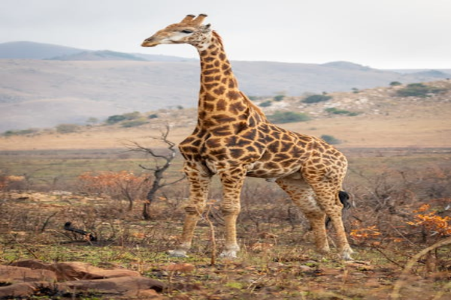

Day 1: Exciting Departure from Delhi





Travel Distance: Explore the city on foot  
Spend the day exploring Nagpur's vibrant markets, historical sites, and beautiful parks. Enjoy a traditional meal at a local vegetarian restaurant.

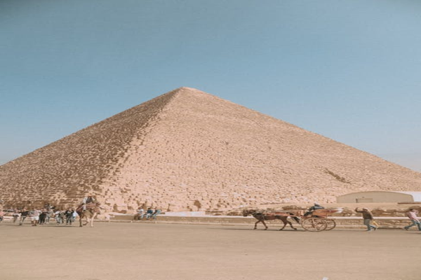

Day 2: Exploration of Nagpur





Travel Distance: 80 km (3 hours by road)  
Embark on an early morning safari at Pench National Park for a chance to spot tigers, leopards, and other wildlife in their natural habitat. Return to Nagpur in the evening for a relaxing dinner.

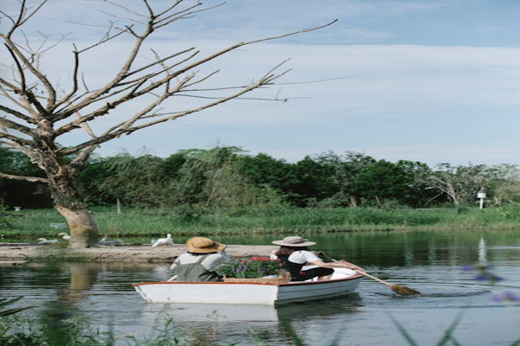

Day 3: Wildlife Safari at Pench National Park





Travel Distance: Explore the city on foot  
Immerse yourself in Nagpur's rich culture by visiting museums, art galleries, and cultural centers. Indulge in some more delicious vegetarian cuisine for lunch.



Day 4: Cultural Immersion in Nagpur





Travel Distance: 10 km (30 minutes by car)  
Visit Deekshabhoomi, a sacred Buddhist monument in Nagpur, and participate in fun activities like meditation or yoga. Enjoy a leisurely evening exploring the local markets.

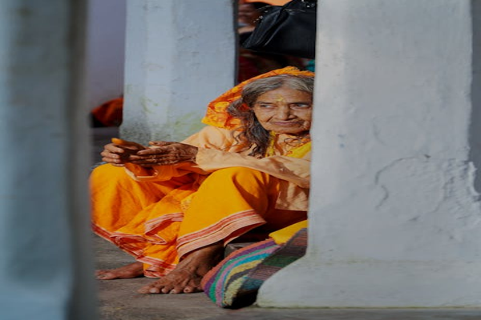

Day 5: Adrenaline-filled Adventure at Deekshabhoomi





Travel Distance: 75 km (2 hours by road)  
Take a day trip to Sevagram Ashram, once home to Mahatma Gandhi, and learn about his life and teachings. Enjoy a peaceful retreat and vegetarian meal on the ashram premises.

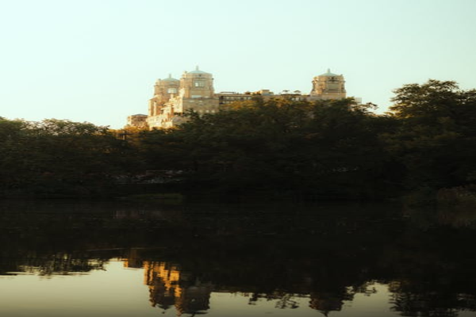

Day 6: Day Trip to Sevagram Ashram





Travel Distance: Explore the city on foot  
Spend the day relaxing at your hotel or exploring Nagpur at your own pace. Treat yourself to a spa day or shopping for local handicrafts.

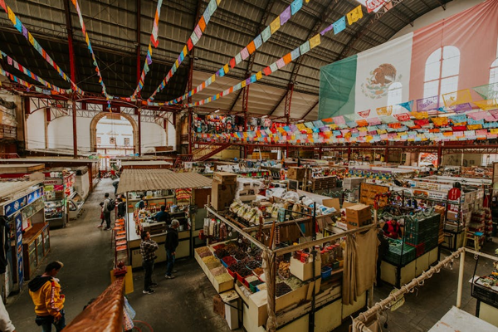

Day 7: Relaxing Day in Nagpur





Travel Distance: Explore the city on foot  
Take a heritage tour of Nagpur, visiting iconic landmarks like the Futala Lake, Zero Mile Stone, and the Sitabuldi Fort. Enjoy a traditional vegetarian dinner at a local restaurant.

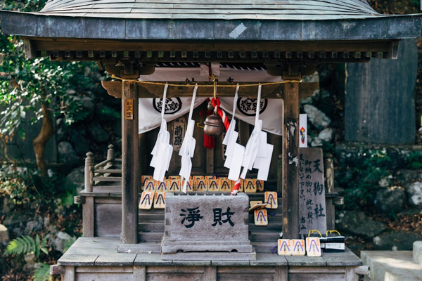

Day 8: Heritage Tour of Nagpur





Travel Distance: 20 km (1 hour by car)  
Join a cooking class to learn how to prepare traditional Maharashtrian dishes using fresh ingredients. Enjoy the fruits of your labor for lunch and dinner.

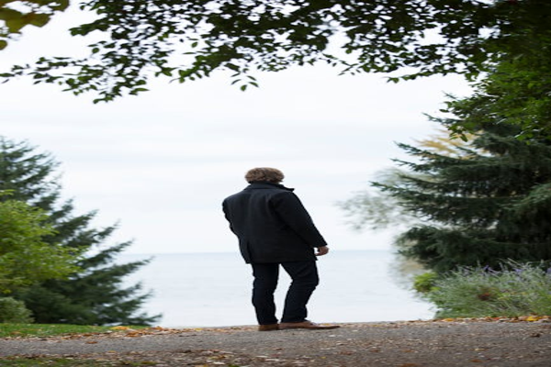

Day 9: Culinary Experience in Nagpur





Travel Distance: 45 km (1.5 hours by road)  
Visit the ancient Ramtek Temple dedicated to Lord Rama and immerse yourself in spirituality and culture. Enjoy a scenic drive back to Nagpur and relax in the evening.

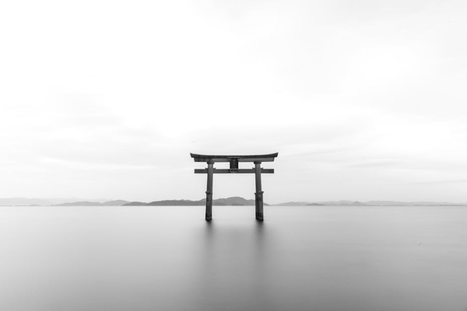

Day 10: Day Trip to Ramtek Temple





Travel Distance: Explore the city on foot  
Spend the day shopping for souvenirs and local handicrafts at popular markets like Sitabuldi Market and Dharampeth Market. Treat yourself to some street food for lunch.



Day 11: Shopping Extravaganza in Nagpur





Travel Distance: 15 km (45 minutes by car)  
Embark on a nature walk around Ambazari Lake, enjoying the serene surroundings and birdwatching opportunities. Have a picnic lunch by the lake and relax in nature.

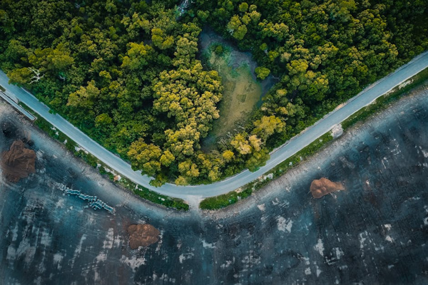

Day 12: Nature Walk at Ambazari Lake





Travel Distance: 10 km (30 minutes by car)  
Spend the day at Krazy Castle, an amusement park in Nagpur, enjoying thrilling rides and fun activities with your friends. Indulge in some snacks and drinks at the park.



Day 13: Adventure Activities at Krazy Castle





Travel Distance: Explore the city on foot  
Enjoy a special farewell dinner at a top-rated vegetarian restaurant in Nagpur, savoring delicious dishes and sharing memories of your unforgettable trip. Spend the evening reminiscing and planning your next adventure.



Day 14: Farewell Dinner in Nagpur





Bid farewell to Nagpur as you catch your flight back to Delhi, carrying with you cherished memories of your fun-filled adventure in the city.

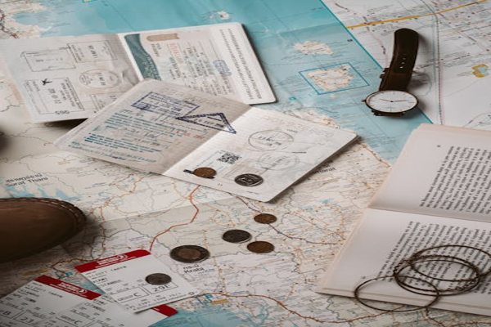

Day 15: Departure from Nagpur